Final proposal

1. Dream of childhood: Magic girls’ magic wand

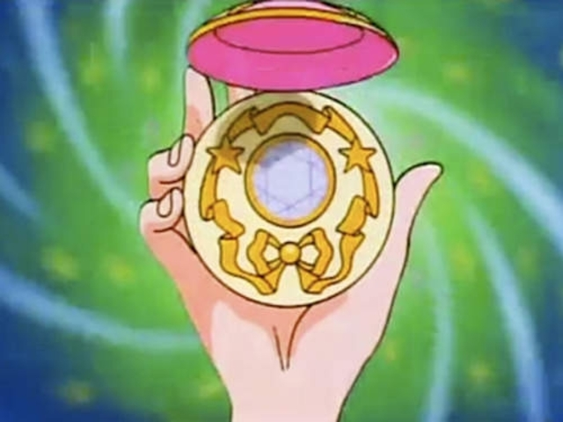

Input:

1.Ball sensor---direction or vibrate sensor

2. sound sensor

Output: Light + sound

Color light, and play the line and music of the animation

Arduino:

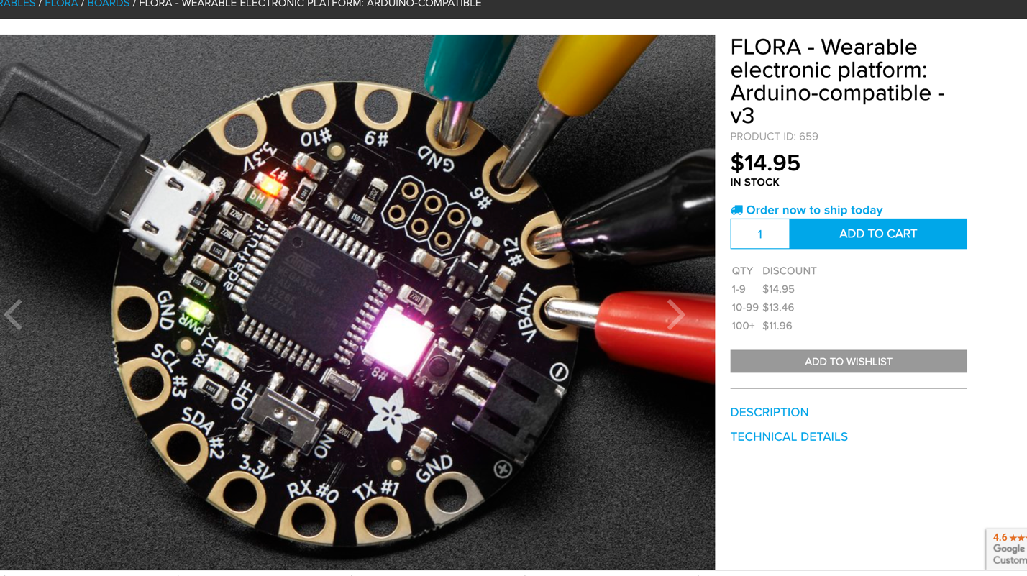

1. Physical game

The improvement of Bonny. Using sound to control a physical game…